Lab9 var 9
Petrukovich Volha
Task 1 1

Task 1
clc;
clear;
%-----Input
x = -10:0.01:10;
z1 = num2str(fzero(@f1, [-3 -2]));
z2 = num2str(fzero(@f1, [2 3]));
z3 = num2str(fzero(@f3, [-3 -2]));
z4 = num2str(fzero(@f3, [2 3]));
str = strcat('f1:z1 = ', z1, ' z2 = ', z2);
figure('Name', 'f1')
plot(x, f1(x));
title(str);
grid on;
figure('Name', 'f2')
title('f2');
plot(x, f2(x));
grid on;
str = strcat('f3:z1 = ', z3, ' z2 = ', z4);
figure('Name', 'f3')
plot(x, f3(x));
title(str);
grid on;
%-----Output
fprintf('TASK1\n')
fprintf(' Input Data\n')
fprintf('---------------\n')
fprintf('\n')
fprintf(' Answer:\n')
%-----------
TASK1
Input Data
---------------
Answer:
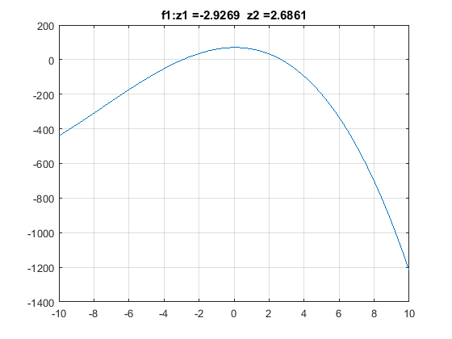
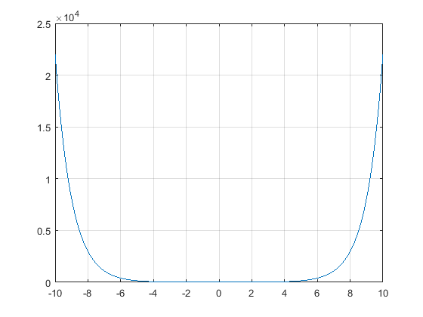
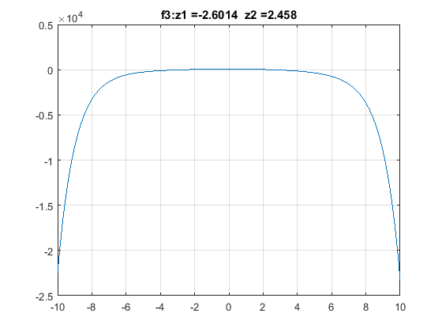
Published with MATLAB® R2017a

